New Delhi, India

November 27, 2024

SOFTWARE REQUIREMENT SPECIFICATION (SRS)

*MyChild Helpline*

Table of Contents

Chapter 1: Introduction 6

1.1 Purpose 6

1.2 Document Convention 7

Chapter 2: System Features 8

2.1 Website 8

2.2 Mobile App 10

2.3 Admin Panel 13

Chapter 3: Scope of Work 18

Chapter 4: Technical Details 20

4.1 Technology Stack 20

4.1.1 Web Application 20

4.1.2 Mobile Application 20

4.2 Hosting Requirements 21

4.2.1 Web Hosting 21

4.2.1 Mobile App Hosting 22

Chapter 5: Functional Requirements 23

5.1 Mobile App 23

5.1.1 Register 23

5.1.2 My Space 24

5.1.3 Information Kiosk 26

5.1.4 Helping Hand 27

5.1.5 Broadcast 28

5.1.6 Accessibility 29

5.1.7 Settings 30

5.2 Admin Panel 32

5.2.1 Login 32

5.2.2 Dashboard 33

5.2.3 Mobile Data 35

5.2.4 Admin 39

Chapter 5: Project Plan 50

Annexure B: Entity-Relationship (ER) Diagram 55

Annexure C: Mobile App Wireframe 56

Annexure D: Admin Panel Wireframe 75

**Revision History**

|  |  |  |  |
| --- | --- | --- | --- |
| Name | Date | Reasons of Changes | Version |
| iTM | 20 November 2024 | The first draft of the SRS developed. | R1 |
| iTM | 27 November 2024 | The first draft of the SRS developed. | R2 |

**Project Details**

|  |  |
| --- | --- |
| Name | Upgrade and maintenance of the MyChild Helpline mobile application |
| Area | Eastern Caribbean Area |
| Agency | UNICEF Eastern Caribbean Area Office, Bridgetown, Barbados |
| Agency Focal Person | Ms. Candice Wallace, Child Protection Officer, UNICEF |
| Agency Email | [cwallace@unicef.org](mailto:cwallace@unicef.org) |
| Development Team | i-Tech Mission |

**Definition, Acronyms and Abbreviations**

|  |  |  |
| --- | --- | --- |
| # | Item | Description |
| 1 | API | Application Programming Interface |
| 2 | APK | Android Package |
| 3 | AWS | Amazon Web Services |
| 4 | CSV | Comma Separated Value |
| 5 | FAQ | Frequently Asked Questions |
| 6 | GB | Giga Byte |
| 7 | HCD | Human Centered Design |
| 8 | HTTPS | Hypertext Transfer Protocol Security |
| 9 | IEC | International Electrotechnical Commission |
| 10 | IP | Internet Protocol address |
| 11 | IPA | iOS App Store Package |
| 12 | ISO | International Organization for Standardization |
| 13 | Mbps | megabits per second |
| 14 | MHPSS | Mental Health and Psychosocial Support |
| 15 | NLP | Natural Language Processing |
| 16 | OS | Operating System |
| 17 | PRINCE2 | PRojects IN Controlled Environments |
| 18 | SDK | Software Development Kit |
| 19 | SRS | Software Requirement Specification |
| 20 | SSD | Solid-State Drive |
| 21 | SSL/TLS | Secure Sockets Layer/Transport Layer Security |
| 22 | T4D | Technology for Development |
| 23 | UI/UX | User Interface/User experience |
| 24 | UNICEF | United Nations Children’s Fund |
| 25 | vCPU | Virtual Central Processing Unit |
| 26 | VMs | Virtual Machines |

# Chapter 1: Introduction

## Purpose

The purpose of this document is to define the requirements for the MyChild Helpline web and mobile applications. The applications were developed by UNICEF partnered with ChildLine Trinidad and Tobago to develop the My ChildLine App - a mobile application which provides direct access to mental health and psychosocial support (MHPSS) in 2020. The app provides children with an array of child-friendly resources. Available in English, Spanish and French, the app connects its users to child protection support services, including direct access to national toll-free hotlines, developmentally appropriate resources and interactive activities.

The app was developed to support children and their families in Trinidad and Tobago, launched in October 2020, and is currently accessible to children and caregivers including migrant children. It is successfully scaled-up to cover an additional 11 countries with a slight variation in the name and design of the app. The app was launched in Antigua and Barbuda, Barbados, Grenada, and St. Vincent and the Grenadines in 2021 and 2022 respectively and will be launched in the other 7 countries in 2024. The app has the potential to be scaled beyond the eastern Caribbean once it meets the necessary criteria for it to be considered a digital public good. Below is a list of app features

* National toll-free helpline numbers in their specific country
* Tele-counselling services
* Location based search for child related services in their respective country
* Information of children’s rights
* Mood tracker
* Password protected diary
* Interactive games
* Child-friendly avatars

The mobile app is supported by a web-based admin panel application which has a restricted access. The regional and national administrators can login in the application to manage user interactions, monitor service requests, and analyze data effectively. There is a website developed that serves as a digital platform to provide information on the mobile app and its usage. While these applications are already developed, there is a need for improvement and enhancement to optimize their functionality and user experience.

The following are the expected deliverables of this phase:

* Upgraded app with enhanced features.
* Documented system architecture and operational responsibilities.
* Vulnerability assessment report with mitigation measures.

The purpose of this report is to provide the detailing of the objectives, scope of work, and a project plan. The report will serve as a foundational document to guide the process of design, development, testing and deployment to ensure that all the stakeholders have a clear understanding of the project’s goals, technical requirements and timelines.

## Document Convention

This project will be managed using effective project management frameworks and proven methodologies such as AGILE and PRINCE2. This will help to increase the visibility, adaptability, alignment, product quality, business value and customer satisfaction. It will also help to decrease the risk. This first documentation is one of the leading documents to help implement this methodology.

# Chapter 2: System Features

The MyChild Helpline platform provides child-friendly resources and services, ensuring accessibility and usability. It comprises of the three applications:

* Website
* Mobile App
* 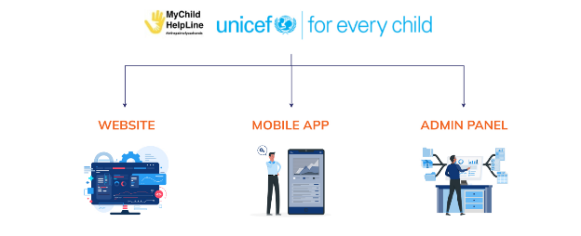Admin Panel

## 2.1 Website

The website serves as a central repository of information and resources supporting the MyChild Helpline initiative. It is as a web-based application that can be accessed without login by visiting the URL <https://www.mychildhelpline.org/>. It includes the following modules:

* Home
* MyChild Helpline App
* Resources
* FAQs
* How to use the app
* Feedback

Below is the brief description of the above modules: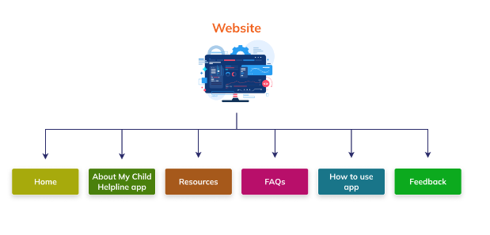

* The **Home** page serves as the landing page of the website. It provides an introduction and features of the MyChild Helpline application, testimonials, and the partners list and their website links. Download links for the app are available for both Android and iOS devices. Additionally, contact information is provided for users seeking further assistance along with the privacy policy document.
* **MyChild Helpline App** module provides detailed information about the MyChild Helpline mobile application, including its features, benefits, and how it can assist children and caregivers in accessing mental health support and resources.
* **Resources** module provides reference materials that aimed at supporting mental health conversations, guidance for teachers, and resources like storybooks for children affected by COVID-19. It also includes links to mental health support guidelines, and online courses offered by organizations such as UNICEF, links to the Pan American Health Organization, and the World Health Organization website.
* **FAQs** module is developed to list the frequently asked questions.
* **How to Use the App** module provides instructions on how to use and navigate the MyChild Helpline app to ensure users can easily access its features and services.
* **Feedback** module allows users to enter their name, email, contact number and message that they want to send.

## 2.2 Mobile App

The mobile application is developed for both the Apple and Android mobile phones and available at App Store and Play Store for download. It comprises of the following modules:

* Register
* My Space
  + Call Us
  + Request for Counselling
  + My Diary
  + My Chill Spot
  + Arcade
  + U Matter Mental Health Chatline
* Information Kiosk
  + My Rights
  + The Parenting Hub
  + Government Services
  + Resources
  + My Child Helpline
  + Nearby Places
  + UNICEF Eastern Caribbean Areas
* Helping Hand
* Notifications
* Accessibility
* Settings

Key enhancements in the Mobile Application –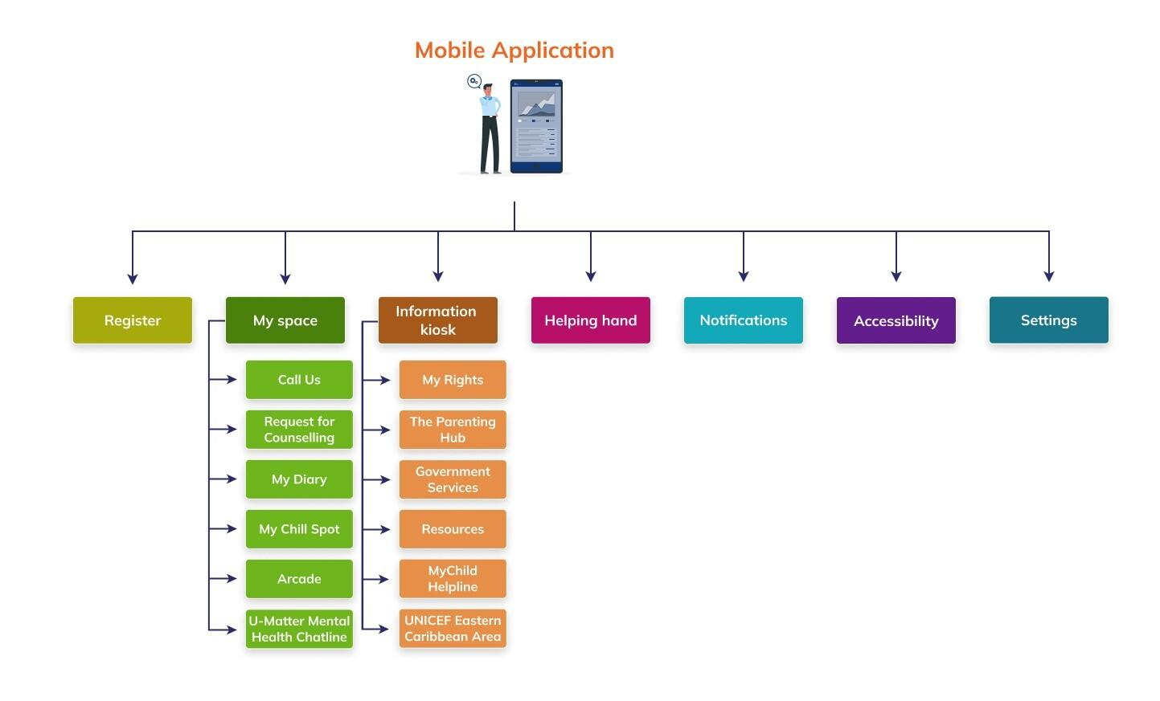

* **Splash Screen** - A splash screen will be designed and integrated to appear before the registration screen. This feature will enhance the app's branding and initial user interaction.
* **District** - The district dropdown in the registration form will be dynamically populated from the database. This will replace the existing static list to ensure real-time updates and accuracy.
* **Avatar -** Users will have the option to either upload a display picture from their local gallery or select an avatar from the available library and customize it with options to select skin tones, hairstyles, and accessories. This will provide a more inclusive and personalized experience for users.
* **AI-Enabled Chatbot -** An AI-enabled chatbot named "Helping Hand" will be available to assist users in navigating the app and interact with them. This feature will serve as a conversational agent powered by artificial intelligence technology like natural language processing (NLP). It will understand, process, and respond to user queries in natural language, providing human-like interaction.
* **Notifications** – Users will be able to view the messages/announcements broadcast by the county administrators.
* **Accessibility Features -** Accessibility options will be available to make the app usable by users with varying abilities. The features will include adjustments of contrast, font size, text spacing.
* **Organizing Modules/Features –** Modules/Features of both the web and mobile app will be reorganized to ease the navigation and usage.

Below is the detailed description of the mobile app modules and their sub-modules –

* The **Register** module will allow the users to register by providing their basic details. Users will be able to enter their name and date of birth and select their preferred language, gender, country, and respective district. They will have the option to set a display picture by either uploading a photo from their phone photo gallery or select an avatar and customize it.
* The **My Space** module will serve as a homepage that will allow to access the following sub-modules-

1. **Call Us**: This sub-module will allow users to call on a dedicated hotline phone number for immediate support.
2. **Request for Counselling**: This sub-module will allow users to book a counselling session with a professional counsellor. The users have to select an appointment date along with their name and contact number and the reason for the appointment.
3. **My Diary**: This sub-module will provide the users a safe private space to express their thoughts and feelings. The users will be able to set a password to access their diary notes.
4. **My Chill Spot**: This sub-module will allow users to engage in calming activities, including guided breathing exercises and "Counting from 10".
5. **Arcade**: This sub-module will serve as a fun and engaging space where users can select and play interactive games. The games will include Tic Tac Toe, Puzzle and Bounce.
6. **U-Matter Mental Health Chatline**: This sub-module will provide a chatline to interact with counselors in real time. It will also provide audio and video calls if appropriate and safe for the users.

The **Information Kiosk** module will serve as a repository of content to be disseminated for the users through this app. It will include the following sub-modules:

1. **My Rights:** This sub-module will allow users to view child rights. The users can also play audio about the child rights.
2. **The Parenting Hub:** This sub-module will redirect users to UNICEF parenting page that provides helpful tips, insights and guidance for parents and caregivers.
3. **Government Services:** This sub-module will list government services available to users in their respective regions.
4. **Resources:** This sub-modulewill provide contact information of services related to children's health, education, and safety. It will provide information about ambulance services, hospitals, social welfare ministries and departments, child protection services, education department, nearby library facilities and police support.
5. **MyChild Helpline:** This sub-module will redirect the users to the MyChild Helpline website.
6. **Nearby Places:** This sub-module will allow users to discover various fun, educational, and interesting locations around them. This feature will help users explore local attractions, fostering engagement and learning opportunities.
7. **UNICEF Eastern Caribbean Areas:** This sub-module will redirect users to the contact information of UNICEF Eastern Caribbean website.

* The **Helping Hand** module will feature an AI-enabled chatbot that will enhance user engagement and navigation. It will serve as a conversational agent powered by artificial intelligence technology like natural language processing (NLP). It will understand, process, and respond to user queries in natural language, providing human-like interaction. Users will be able to enter queries and get suggestions from the bot.
* The messages/announcements broadcasted by the country administrators can be viewed by the users in the **Notifications** feature. This will be present on the top of the home page and will notify the user when a new message is received and they will be able to view these messages.
* The **Accessibility** feature will be present on the top of all pages and will provide options to enhance app usability for users with varying abilities. The features will include adjustments of contrast, font size, text spacing.
* The **Settings** module will allow users to customize their mobile app. Users will have the option to update their profile including their name, display picture, preferred language and registered location. Additionally, the module will include important information about the app, offer an option for submitting feedback, and provide an option to view the privacy policy. It also features sections on how to use the app and frequently asked questions (FAQs). Users will also be able to delete their account in this module.

## 2.3 Admin Panel

This will be a web application and will have restricted access. Users with valid credentials will be able to login to access this application. The first user of this application will be a super admin which will be pre created in the system. The super admin will further create and manage the other users of this application. The following will be the modules of this application.

* Login
* Dashboard
* Mobile Data
* Mobile App Users
* Counselling
* Mood Tracker
* Feedback
* Admin
* Admin Users
* Classification
* Helpline
* Broadcast
* Mobile App Customization
  + U-Matter Chatline
* Language

The following section provides a brief explanation of the admin panel modules.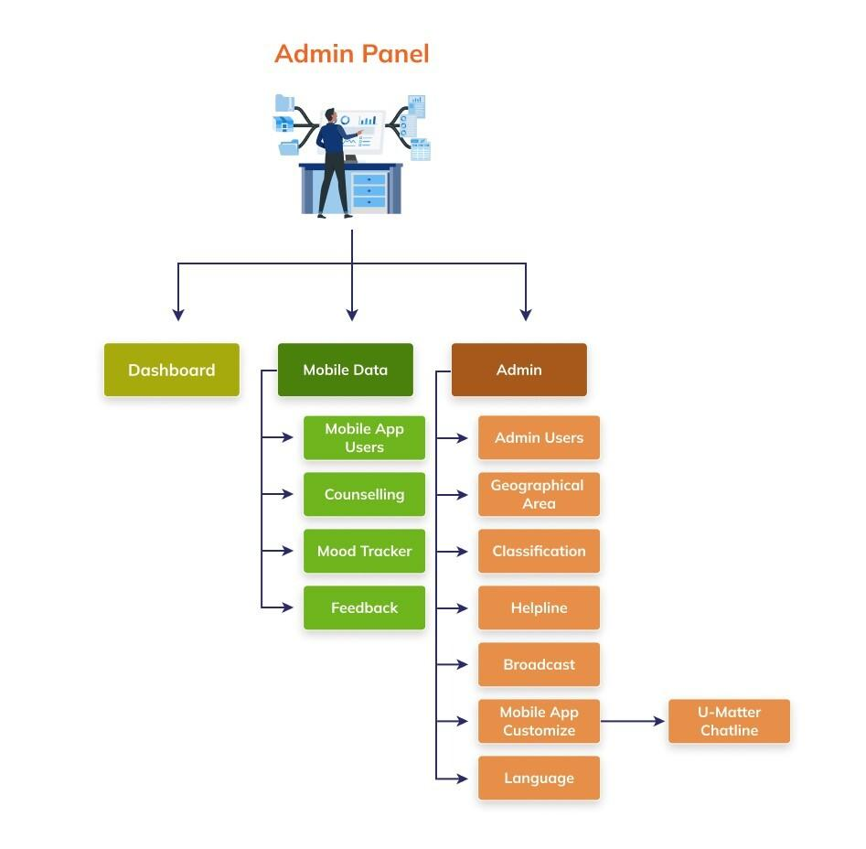

* The **Login** module will allow the users to get access to the application. Users with valid credentials will be able to enter their email and password for authentication.
* The **Dashboard** will present the aggregated data entered by the mobile users. It will present the aggregated data of mobile app users, counseling sessions and moods of the users. The data will be presented using the appropriate graphs to ease the analysis. The charts will present the data disaggregated by gender, age-group, time period. It will filter the data by geographical location like country and its first sub-national levels.
* The **Mobile Data** module will manage the data of mobile app users. This will comprise of the following sub-modules:
* The **Mobile** **App Users** sub-module will allow admins to view the anonymized details of mobile app users. It will present the users age, gender, geographical location (country and district) and selected language. It will filter the details by geographical location, age-group, gender and registration date.
* The **Counseling** sub-module will allow users to view the counseling sessions booked by the mobile app users. The details for each counseling session will include name, contact number, gender, age, selected language, geographical location, appointment date. reason and message. The admins will have the option to edit the counseling session details by adding their comments, date conducted and setting the counseling session status to closed after the session is conducted. It will filter the details by geographical area, age-group, gender, appointment date range and session conducted date range.
* The **Feedback** sub-module will allow users to view the feedback details submitted by the mobile app users. The details will include the message and date submitted. The phone and email will be presented if they were entered by the users. The admins will have the option to delete feedback. It will filter the details by geographical area, age-group, gender and date entered.
* The **Mood Tracker** sub-module will present a timeline-based aggregation of user psychosocial needs. It will present the aggregated data of moods submitted by the mobile users. It will present the total, mean, median and mode calculations of the moods of the users for a given time-period. It will also allow us to view these calculations by geographical area, specific mood and time-period.
* The **Admin** module will allow you to create and manage the master data. This will comprise of the following sub-modules:
* The **Admin** **Users** sub-module will allow the super admin to create and manage the account of other users of the admin panel application. It will present the details of the country and regional administrators. The details will include the admin name, email, password and the country (or countries) assigned. In this module the super admin can create new users, edit/delete the existing users and also reset their passwords.
* The **Geographical Area** sub-module will allow the super admin to create and manage the countries and their sub-national list. The super admin can add, edit and delete the countries and their sub-national (districts).
* The **Classification** sub-module will allow the super admin to create and manage the master lists used in the mobile app. The super admin can add, edit and delete the helpline categories in this sub-module.
* The **Helpline** sub-module will manage the list of emergency and support services of their assigned country. These services list will be seen by the mobile app users when using the MyChild Helpline App. The admins will be able to add, edit and delete the country-specific helpline details that includes the Geographical area, Organization, Helpline category, Helpline number, Emergency service status, Address, Website URL, Contact number, Email and Geolocation. It will filter the details by geographical area, helpline category and emergency service status.
* The **Broadcast** sub-module will allow admins to broadcast messages to the mobile app users. The admins will be able to create and manage the broadcast messages for their assigned country users. The message details will include the Title, Sub-title, Message, Message category, Message status (Sent/Pending) and Date sent. The admins will be able to edit, delete and send their created messages. It will filter the details by geographical area, message category and sent date.
* The **Mobile App Customization** sub-module will allow customization the mobile app features by respective countries. It will have a sub-module “**U-Matter Chatline**”. This sub-module will allow the super admin to add and manage the chat application link by country.
* The **Language** sub-module will translate the application strings from English to the other required Spanish, and French. It will have options to export and import language templates, enter/update strings from one language to the other language.

# Chapter 3: Scope of Work

The broad scope of work includes improvements in functionality, security, user interaction, performance and documentation. The tasks under this project are categorized as project management, database development, software development, software testing, technical documentation, training, web and cloud management. All tasks will be performed under the guidance of UNICEF Child Protection Officer and ICT Associate. The objective is to upgrade both the web and the mobile applications. It is important to ensure compliance with digital public good criteria and other UNICEF standards, integrating sound T4D and data security principles throughout the project lifecycle.

Following is the scope of work.

* To review and understand the existing admin panel and mobile applications.
* To discuss and finalize the upgrades required in the database, admin panel and mobile app. Draft and finalize inception report.
* To upgrade the mobile app's user interface and graphics with a Human Centered Design (HCD) approach. Implement feature enhancements to ensure usability for all users, including those with varying abilities and adhering to principles of user-centric design and accessibility standards.
* To develop an AI-powered assistant that can respond to basic inquiries to improve the usage of the features of mobile app and to obtain information on support available.
* To have a notification feature to allow messages broadcasted to the mobile app users.
* Enhance and expand the avatars in the mobile app.
* Upgrade the admin panel to
  + Provide filters in all the modules including the dashboard to allow data view by age, gender, country.
  + Restrict users to have access to their assigned country-specific data while those with all countries access should be able to view all data.
  + Show data over time for trend analysis (quarterly) especially mood tracker.
  + Allow super admin to add and manage countries and the first sub-national level (district) for future extension.
  + Allow selection of districts during signing in the mobile app.
  + Broadcast messages/announcements to the mobile users.
  + Allow to customize and manage the country specific chat line for the mobile users.
  + Upgrade the Counselling module to allow the admin to close and reopen cases.
* Ensure the web and mobile applications are secured and compliant to standards ISO/IEC 25010.
* To develop detailed user guides and training manuals explaining the features of the platform.
* To build the capacity of the stakeholders and partners to use and manage the platform.
* To install, configure and deploy the system on the staging and production server, perform User Acceptance Test (UAT).
* To provide technical support and service to maintain the system.

# Chapter 4: Technical Details

## 4.1 Technology Stack

Both the web and mobile applications will be developed using the following environment and tools. See **Annexure E: Software Architecture.**

### 4.1.1 Web Application

Operating System Ubuntu v22.04 (latest version)

Front-end Language JavaScript vES2015, HTML v5.0, CSS v3.0

Visualization Library ECharts v5.5.1

Front-end Framework AngularJS v16

Back-end Language Node.js v18, PHP v7.4

Back-end Framework Express v4.21.1, Laravel v11

Database Tool MySQL v8.1

Server Type Apache v2.4*, Docker v20.10.7, Docker composer v1.27.0

Version Control                     Git v2.42, GitHub/GitLab Integration

### 4.1.2 Mobile Application

Operating System                 MacOS v15.1.1 Sequoia  
Development Language         React Native v0.7635  
Front-end Framework           React Native Framework  
Back-end Communication     REST APIs  
Cloud Services                      Firebase v11  
Server Type                           Node.js v18  
Build Tools                            Gradle v8.10.2 (Android), Xcode v16.1 (iOS)  
Version Control                     Git v2.42, GitHub/GitLab Integration  
Testing Tools                         Jest v29.6.3 (Unit Testing)  
Emulators                             Android (SDK v35) , iOS(SDK v16)

## 4.2 Hosting Requirements

### 4.2.1 Web Hosting

The admin panel and the API gateway for the mobile application will be hosted in the cloud-based servers and will be accessible via web browsers on desktop and mobile devices. It will be compatible with major browsers such as Chrome, Firefox, Safari, and Edge. Following will be the requirements to deploy the platform:

* Reliable and scalable web/application server such as Apache, Tomcat.
* Database server to host the database such as MySQL.
* Cloud infrastructure such as AWS, Other cloud services.
* Operating systems such as Ubuntu and other software components to host the platform.
* Version control system to manage code such as GitLab.
* SSL/TLS certificate to secure data transmission between users and the web server.
* Public IP and domain.
* Firewall to protect the network and systems from unauthorized access and attacks.
* Scripts to take regular backups and a robust disaster recovery plan.
* Stable internet connection.

It will need an internet connection to be deployed on the web servers which are termed as Virtual Machine (VM). One VM can be used to host the Admin Panel, the API gateway and the database. Below are the suggested VM specifications:

Processor 4 vCPU

Memory 8 GB

Storage 200 GB SSD

Internet Connection 100 Mbps recommended

Ports80, 27017, 6379, 443, 21, 22

Web servers shall be protected by the firewall. A public IP and dedicated domain will be needed. A web master shall be assigned the task of managing, troubleshooting and maintaining the web server. There shall be adequate uptime of the web server. A decent internet connection will be required for the web server to manage the expected network traffic.

*Note: The above specifications are recommended requirements, though the platform will be able to be deployed on lower specification web-based instances with options of elastic storage and processor. Port 80 would be required only during the development process*

### 4.2.1 Mobile App Hosting

To host a mobile app on Apple's App Store and Google’s Play Store there are technical, policy compliance, and operational requirements. The following explains the requirements.

* **Developer Program Membership** is required to submit apps to the App Store and Play Store.
* **Setup the development environment** preferably on an Apple Mac machine. The integrated development environment (IDE) is required to set up the Xcode and Android Studio that supports the latest version of iOS and AndroidSoftware Development Kit (SDK).
* **Device Compatibility** to test the app on various devices and screen sizes like iPhones, iPads, Android phones and tablets.
* **App Binary** the iOS-based application will be submitted in an IPA (iOS App Store Package) format and the Android-based application will be submitted in APK (Android Package).
* **App Size** the maximum compressed size of IPA should approximately be 200 MB and of APK should be 150 MB.
* **App Metadata** will include a name, description, screenshots, icons and promotional text.
* **Privacy Compliance** a privacy policy URL is mandatory for apps collecting user data. The app must comply with both Apple and Google developer program policies.
* **User Data Policy** the app should comply with both Apple and Google user data policies.
* **App Submission Process** includes creating app store records, creating app packages, add app metadata, upload the build and submit for review.
* **Beta Testing, App Updates and Accessibility features** are the additional tasks that should be performed to ensure the successful deployment of the mobile apps.

# Chapter 5: Functional Requirements

The system comprises of three applications -

* Website
* Mobile Application
* Admin Panel

The detailed functional requirements of both the Mobile App and the Admin Panel are explained below.

## Mobile App

### Register

The Register module will allow users to register for using the mobile app.

**Functional Requirements**

|  |  |
| --- | --- |
| REQ 1 | Display a helping hand mascot at the top with a relevant message. |
| REQ 2 | Allow users to register with the following validations -   * **Language** should be selected and cannot be blank. * **Gender** should be selected and cannot be blank. * **Country** should be selected and cannot be blank. * **District** should be selected and cannot be blank. * **Date of Birth** should be entered and cannot be blank. * **User Name** (What should we call you) should be entered. * **Avatar** or **Picture** should be selected as a display picture. |
| REQ 3 | Provide an option to set a custom avatar.   * **Face Features**: Select facial shapes, skin tones, eye shapes, eyebrows, eye colors, hair, hair color. nose, and mouth. * **Accessories**: Add glasses, hats, earrings, or other accessories. * Provide an option to discard changes and return to the default or previous avatar design. * Provide an option to save the customized avatar and apply it to the user’s profile.   All changes should be updated in real time, allowing users to see their customizations instantly. |
| REQ 4 | Display a disclaimer informing the user that their personal data will be kept confidential. |
| REQ 5 | Provide an option to view privacy policy and Terms and Conditions documents. |
| REQ 6 | Provide an option for the users to acknowledge their agreement to the privacy policy and terms and conditions. |
| REQ 7 | Provide an option to navigate to the next screen of the mobile app. |
| REQ 8 | The Next button should only be enabled once all mandatory information has been entered and the user has agreed that they read the privacy policy and terms & conditions. |

### My Space

**Description**

This module will provide quick links to personalized features and services, such as direct contact options for support, booking counseling appointments, writing personal notes, engaging in calming activities like guided breathing exercises and "Counting from 10 to 1," as well as interactive games. It will also provide a link to a chat line for connecting with support personnel in a specific country. Below is the functional requirement of this module.

**Functional Requirements**

|  |  |
| --- | --- |
| REQ 1 | Provide an option to access the “**My Space**” module from the footer navigation bar. |
| REQ 2 | Provide an option to access the **“Call Us”** sub-module. |
| REQ 3 | Provide an option to call the support executive via **Phone**, **Skype**, or **WhatsApp** specific to the user’s country when they select the **Call Us** sub-module. |
| REQ 4 | Provide an option to access the **“Request for Counselling”** sub-module. |
| REQ 5 | In Request for Counselling sub-module, provide option to book a counselling appointment with the following validations –   * Counselling date should be entered and it cannot be blank * Reason of booking a counselling should be selected and it cannot be blank * First name should be entered and it cannot be blank * Last Name should be entered and it cannot be blank * Telephone number should be entered and it cannot be blank. |
| REQ 6 | Provide an option to book the counselling appointment. |
| REQ 7 | Provide an option to cancel the appointment. |
| REQ 8 | Provide an option to access the **“My Diary”** sub-module. |
| REQ 9 | In Diary sub-module, provide option to add daily journal with the following validations –   * **Title** should be entered and it cannot be blank. * **Description** should be entered. |
| REQ 10 | Provide an option to confirm saving a note. A toaster message should appear after saving, notifying the user that the note has been successfully saved. |
| REQ 11 | Provide an option to delete all notes. A confirmation popup should appear, and upon clicking "Yes," all notes should be deleted. |
| REQ 12 | Provide an option to delete selected notes. A confirmation popup should appear, and upon clicking "Yes," only the selected notes should be deleted. |
| REQ 13 | Provide encryption to ensure the privacy and security of all notes stored within the application. |
| REQ 14 | Provide an option to access the **“My Chill Spot”** sub-module. |
| REQ 15 | In My Chill Spot sub-module, provide options to –   * **Use a breathing exercise tool**, with visual cues to guide users through structured breathing cycles, helping them relax and reduce stress. * **Use a counting exercise tool**, allowing users to focus on a simple counting exercise for mindfulness. |
| REQ 16 | Provide option to access **“Arcade”** sub-module |
| REQ 17 | In Arcade sub-module, provide options to select and play on the games from the following options –   * Tic Tac Toe * Puzzle * Bounce |
| REQ 18 | Provide an option to access the **“U-Matter Mental Health Chatline”** sub-module**.** Redirect the user to the WhatsApp chat link of their registered country when this option is selected. |

### Information Kiosk

**Description**

This module provides users with a centralized hub to access contact information for essential child help services and other relevant resources. It also includes external links to crucial information related to child welfare. Below is the functional requirement of this module.

**Functional Requirements**

|  |  |
| --- | --- |
| REQ 1 | Provide an option to access the **“My Rights”** sub-module. |
| REQ 2 | In My Rights sub-module, display step-by-step information about the user’s rights, categorized by topics and detailed descriptions. |
| REQ 3 | Provide an option to access **“The Parenting Hub”** sub-module. |
| REQ 4 | The user should be navigated to the UNICEF web page with detailed information related to good parenting when they select the “The Parenting Hub” sub-module. |
| REQ 5 | Provide an option to access the **“Government Services”** sub-module. |
| REQ 6 | The user should be navigated to the government services webpage when they select the “Government Services” sub-module. |
| REQ 7 | Provide an option to access the **“Resources”** sub-module. |
| REQ 8 | In the Resources sub-module, provide options to access country specific–   * Contact information of **Ambulance services** * Contact information of **Health services** * Contact information, website link of **Ministry of Health and Social Development.** * Contact information and website link of **Department of Social Development.** * Contact information **Child Protection services.** * Contact information and Website link of **Library(s)** * Contact information of **Police.** * Contact information of the **Department of Education.** |
| REQ 9 | Provide an option to access the **“MyChild Helpline”** sub-module. |
| REQ 10 | The user should be navigated to the about page MyChild Helpline platform. |
| REQ 11 | Provide an option to access **“UNICEF Eastern Caribbean Area”** sub-module. |
| REQ 12 | The user should be navigated to the about page UNICEF in Eastern Caribbean area webpage. |

### Helping Hand

**Description**

This module will provide an AI-enabled chatbot that will enhance user engagement and navigation. It will greet users by asking about their mood and suggest relevant modules based on their responses. Users can also type queries, and the chatbot will provide results based on trained keywords, helping locate features or modules. This child-friendly feature ensures an intuitive and supportive app experience. Below is the functional requirement of this module.

**Functional Requirements**

|  |  |
| --- | --- |
| REQ 1 | Display a **Helping Hand -** anAI enabled chatbot after the user logs into the mobile app. |
| REQ 2 | Provide an option to also access “**Helping Hand**” chatbot from the navigation bar at the bottom. |
| REQ 3 | A chat box should open when the user clicks on the Helping Hand option and a greeting message should be displayed (e.g., "Hi there! How are you feeling today?") |
| REQ 4 | Provide users with an option to select their mood from the following list -   * Happy * Excited * Loved * Sad * Angry * Depressed * Stressed * Guilty * Lonely * Resilient   After the user selects a mood, provide suggestions or information aligned with their choice. |
| REQ 5 | For example, if the user selects a positive mood (Happy, Excited, or Loved), provide users with an option to **–**   1. Play games, navigating the user to the **Arcade** sub-module where they can enjoy interactive games. 2. Learn more about the app, redirecting the user to the about page MyChild Helpline platform. 3. Write notes, navigation the user to the **My Diary** module where they can add, save, and organize their notes. |
| REQ 6 | Provide an option to type queries in the chat, with the chatbot responding by directing them to the appropriate module or providing helpful information based on trained keywords. |
| REQ 7 | Provide an option to close chatbot. |

### Broadcast

This module will allow users to view their country-specific messages. It will allow users to stay informed about relevant updates and alerts. Below is the functional requirement of this module.

**Functional Requirements**

|  |  |
| --- | --- |
| REQ 1 | Show a notification icon at the top-right corner on all screens to access the messages. |
| REQ 2 | In the notification screen, display the list of messages grouped by date (e.g., "Today," "Yesterday") in a scrollable format. |
| REQ 3 | Provide options to view the title, description, and timestamp for each broadcast message in a card format. |
| REQ 4 | Provide an option to delete selected messages. A confirmation popup should appear, and upon clicking "Yes," only the selected message should be deleted |
| REQ 5 | Provide an option to delete all messages. A confirmation popup should appear, and upon clicking "Yes," all messages should be deleted. |
| REQ 6 | The unread messages should be highlighted with a distinct background color, while older messages should be displayed with faded background. |
| REQ 7 | Display a placeholder message (e.g., "No Broadcast Messages Available") if no messages exist |
| REQ 8 | Provide a navigation button to return to the previous screen |

### Accessibility

The Accessibility module will provide options to enhance usability for individuals with disabilities. Features will include managing contrast, highlighting links, managing font size, and adjusting text spacing.

**Functional Requirements**

|  |  |
| --- | --- |
| REQ 1 | Provide an **Accessibility** icon next to the notification icon at the top right corner of the application. |
| REQ 2 | Provide an option to **Manage Contrast** for improved visibility. Provide the following actions under this option –   * Invert Colors * Dark Contrast * Light Contrast |
| REQ 3 | Provide an option to **Highlight** **Links** within the app to enhance navigation. |
| REQ 4 | Provide an option to enlarge text that should have four font size options (Small, Medium, Large, Extra Large) for users to select based on their preferences. |
| REQ 5 | Provide an option to adjust text spacing that should allow to manage spacing at three levels –   * Light Spacing * Moderate Spacing * Heavy Spacing |
| REQ 6 | Ensure the accessibility features are toggled in real-time that should reflect changes immediately on the app interface. |
| REQ 7 | Show this option throughout the app so that users can enable or disable features conveniently at any time. |

### Settings

The **Settings** module will allow users to customize their app experience. Users will be able to change their name, select an avatar, and update their preferred language and registered country. Additionally, the module will include important information about the app, offer a platform for submitting feedback, and will outline the privacy policy.

**Functional Requirements**

|  |  |
| --- | --- |
| REQ 1 | Provide an option to change the user's name, displaying the current name and allowing the user to enter a new one. |
| REQ 2 | Provide an option to save the username. The username should be updated once the new name is confirmed and saved. |
| REQ 3 | Allow users to update their **Avatar** by accessing the avatar selection interface, which should include the following features –   * A default user image should be displayed at the top of the screen, with an option to customize the avatar, reflecting all changes in real-time. * Provide tabs (e.g., Mouth, Eyes, Eyebrows, Top) for selecting and customizing specific avatar features. * Provide a selection grid, allowing users to choose from various options for each feature. * Provide an option to discard changes and return to the default or previous avatar design. * Provide an option to save the customized avatar and apply it to the user’s profile.   The user image should be updated after confirming and saving the new avatar. |
| REQ 4 | Provide an option to change the app’s language to English, Spanish or French, showing the currently selected language below the option. |
| REQ 5 | Display the user’s registered country name. |
| REQ 6 | Provide a toggle button to set diary lock and app lock functionalities. |
| REQ 7 | Provide an option to view app version details under "About MyChild Helpline." |
| REQ 8 | Provide a feedback section for users to submit comments, suggestions, or issues related to the mobile app. |
| REQ 9 | Provide options to read privacy, data collection and data sharing policies. |
| REQ 10 | Provide an option to guide users on "How to Use the App". |
| REQ 11 | Provide an option to view commonly asked questions. |
| REQ 12 | Provide an option to adjust the font size for accessibility. |
| REQ 13 | Include an "Accessibility, Display, and Language" section for additional customization and accessibility options. |
| REQ 14 | Provide a "Delete Account" option with a clear and distinguishable design (e.g., red color) to emphasize its importance and caution. |
| REQ 15 | Allow users to navigate back to the previous screen. |

## 5.2 Admin Panel

### 5.2.1 Login

**Description**

The **Login** module is the first access point to get into the admin panel application. Users with valid credentials will be able to enter their email/username and password for authentication.

**Functional Requirements**

|  |  |
| --- | --- |
|  | Provide a textbox to enter **Username** or **Email ID** and **Password** along with the option to view the entered password.   * Check for the valid Email ID and show this error message “*Please enter a valid Email ID.*” if the Email ID is invalid. * Check for the valid password. |
|  | Ensure the password remains obscured by default. |
|  | Provide an **Eye** button alongside the password textbox to toggle and view the entered password. |
|  | Provide an option to enter a **CAPTCHA** to prevent automated logins and also provide a refresh button to generate a new CAPTCHA. |
|  | Show this error message “*Captcha entered is incorrect. Please try again.*” when the captcha is entered incorrectly and allow the user to reattempt. |
|  | Provide a **Login** button.   * Enable the "Login" button only when the correct Email ID, Password and CAPTCHA is entered. |
|  | Show a popup for **Forgot Password** when the "Forgot Password" option is selected.   * Provide a textbox for entering the Email ID where password reset instructions will be sent. * Check for a valid Email ID format and display this error “Please enter a valid Email ID.” if the format is incorrect. * Provide a "Submit" button to confirm. * Include a "Back" button to return to the login page. |
|  | Show **Welcome Page** after the successful login. |
|  | Allow navigating back to the welcome page from another module by clicking on the portal logo. |

### Dashboard

**Description**

This module provides summarized data on the number of feedback, blogs, users, counseling open and counseling closed. It also presents data on total numbers of users and mood tracker by gender and country using the column chart and stacked bar chart respectively. It allows administrators to monitor the counseling data by country that is presented using the column chart visualization.

**Functional Requirements**

|  |  |
| --- | --- |
|  | Provide a **Geographical Area** dropdown along with an arrow icon at the top of the Dashboard to allow data filtering based on the selected area. |
|  | Open a pop-up window when clicking on the arrow icon and show a hierarchical list of countries and their corresponding sub-national areas.   * Include an "All" option to display data for all areas and set this as the default selection. * Allow selecting multiple countries and sub-nationals. |
|  | Display the following information for the selected geographical area –   * Show the count of “Total Users” registered using the mobile application. * Show the count of “Counseling Requests”. * Show the number of counseling requests closed in the past 30 days. * Show the average time taken to resolve counseling requests (in days). * Show the total number of “Feedback” received. |
|  | Provide a “**Users”** widget below the summary section on the Dashboard. This widget should provide visual representation of registered users using a pie chart. Provide the following options and validations in the Users widget –   * Provide an “Age Group” dropdown to filter data based on selected age groups. By default, show “All’ option as selected. * Show the legend for the data at the bottom of the widget. * Provide an option to select “Date Range” and filter data based on the selected time period. * Provide a “Burger Menu” at the top right corner that should allow changing the current visualization to Line Chart, Bar chart, Column chart and Pie Chart. Provide options to Download, Full screen and Share as well. |
|  | Provide a “**Counselling”** widget next to the Users widget. This widget should provide visual representation of counselling registered using a stacked bar chart. Provide the following options and validations in the Counselling widget –   * Provide an “Age Group” dropdown to filter data based on selected age groups. By default, show “All’ option as selected. * Show the legend for the data at the bottom of the widget. * Provide an option to select “Date Range” and filter data based on the selected time period. * Provide a “Burger Menu” at the top right corner that should allow changing the current visualization to Line Chart, Bar chart, Column chart and Pie Chart. Provide options to Download, Full screen and Share as well. |
|  | Provide a “**Mood Tracker”** widget at the bottom of the page. This widget should provide visual representation of moods registered using a stacked column chart. Provide the following options and validations in the Mood tracker widget –   * Provide an “Age Group” dropdown to filter data based on selected age groups. By default, show “All’ option as selected. * Show the legend for the data at the bottom of the widget. * Provide an option to select “**Date Range**” and filter data based on the selected time period. * Provide a “**Burger Menu**” at the top right corner that should allow changing the current visualization to Line Chart, Bar chart, Column chart and Pie Chart. Provide options to Download, Full screen and Share as well. |
|  | Show **User** icon at the top left corner of the module with option to Edit Profile, Change Password and Logout. |

### Mobile Data

The Mobile Data module will manage the data of mobile app users. It will contain the following sub-modules – Mobile App Users, Counseling, Feedback and Mood tracker. Below is the functional requirement for each of these sub-modules -

#### 5.1.3.1 Mobile App Users

**Description**

The Mobile App Users sub-module will allow the admins to view the anonymized details of mobile app users to ensure exposing their personal information. It will present the user's age, gender, geographical area (country and sub-national) and selected language. It will filter the details by geographical area, age-group, gender and registration date.

**Functional Requirements**

|  |  |
| --- | --- |
|  | Show the existing list of the mobile app users in a table grid by pages along with pagination options to customize the view. |
|  | Show the following columns in the table grid –   * Serial Number (#) * Gender * Age * Language * Geographical Area (Level 1 | Level 2) * Registration date |
|  | Provide an option to **Search** and **Sort** the existing list. |
|  | Provide option to **Filter** the list by Age, Gender, Registration date and Language. |

#### Counselling

**Description**

The **Counseling** module will allow the admins to view the counseling sessions booked by the mobile app users. The details for each counseling session will include user name, contact number, gender, age-group, selected language, geographical location, date entered. reason and message. The admins will have the option to edit the counseling session details by adding their comments, date conducted and setting the counseling session status to closed after the session is conducted. It will filter the data by geographical area, age-group, gender and date entered.

**Functional Requirements**

|  |  |
| --- | --- |
|  | Provide a **Geographical Area** dropdown along with an arrow icon at the top of the module to allow data filtering based on the selected area. |
|  | Show the existing list of the counselling appointments in a table grid by pages along with pagination options to customize the view. |
|  | Show the following columns in the table grid –   * Serial Number (#) * Geographical Area * Name * Contact Number * Gender * Age * Language * Appointment Date * Reason * Message * Comment * Closed (Yes or No) * Action |
|  | By default, show the **Message** and **Comment** in maximum two lines in the table grid along with an arrow icon to view the full text in a pop-up view. |
|  | Provide an option to **Search** and **Sort** the existing list. |
|  | Provide an option to **Edit** the “Comment” and “**Update Status**” in the dropdown under the action column for each record. |
|  | Provide options to **Delete** an appointment record in the dropdown under the action column. A confirmation box should appear after clicking on the delete button to confirm the deletion. |
|  | Provide a **Filter** option to filter the records by –   * Name * Contact Number * Gender * Age * Area * Closed * Appointment Date |

#### Mood Tracker

**Description**

The Mood Tracker module will present a timeline-based aggregation of user psychosocial needs. It will present the aggregated data of moods submitted by the mobile app users. It will present the total, mean, median and mode calculations of the moods of the users for a given time-period. The admins will be able to view these calculations by geographical area, specific mood and time-period.

**Functional Requirements**

|  |  |
| --- | --- |
|  | Provide a **Geographical Area** dropdowns along with an arrow icon at the top of the Dashboard to allow data filtering based on the selected area. |
|  | Provide a **Mood** dropdown to filter the data based on mood registered. |
|  | Provide an option to select “**From**” and “**To**” date to view data based on selected time period. |
|  | Show the following columns and related information in the table grid –   * Serial Number (#) * Geographical Area (Level1 | Level2) * Mood * Count * Mean * Median * Mode |

#### Feedback

**Description**

The **Feedback** module will allow the admins to view the feedback details submitted by the mobile app users. The details will include the message and date submitted. The user’s name, phone and email will be presented if they were entered by the users. The admins will have the option to delete feedback. It will filter the details by geographical area, age-group, gender and date entered.

**Functional Requirements**

|  |  |
| --- | --- |
|  | Provide a **Geographical Area** dropdown along with an arrow icon at the top of the module to allow data filtering based on the selected area. |
|  | Show the existing list of the feedback in a table grid by pages along with pagination options to customize the view. |
|  | Show the following columns in the table grid –   * Serial Number (#) * Geographical Area (Level1 | Level2) * Name * Email ID * Contact Number * Date * Message * Action |
|  | Provide an option to **Search** and **Sort** the existing list. |
|  | Provide the option to **Delete** the record in a dropdown under the action column. A confirmation box should appear after clicking on the delete button to confirm the deletion. |

### Admin

The **Admin** module will manage all the master data. It will have the following sub modules – Admin Users, Geographical Area, Classification, Helpline and Broadcast. Below is the functional requirement for each of these sub-modules -

#### Area

**Description**

This module will allow authorized users to manage the master list of the geographical areas. It will have the options to add, edit, import, export and show/hide the areas.

**Functional Requirements**

|  |  |
| --- | --- |
| REQ 1 | Show the existing list of the areas in a table grid by pages and provide an option to set the number of areas per page. |
| REQ 2 | Provide options to search, sort and navigate the existing area list. |
| REQ 3 | Provide options to **Add** and **Edit** an area and its details. |
| REQ 4 | Provide option to **Delete** an area and its details with following validations:   * Show the count of associated records and ask the user to confirm deletion. * Delete all the associated records after confirmation. |
| REQ 5 | Provide option to **Show/Hide** an area and its details with following validations:   * Show/Hide the area and its details throughout the applications. * Show/Hide all the associated records. * Do not allow data entry and data import for the hidden area. |
| REQ 6 | Allow adding a new area and its details with the following validations:   * Parent Areashould be selected when adding area under a root area. * Area ID should be selected and it cannot be blank.   *A standard ISO format for ID can be followed for example ANG is the Area ID for Anguilla which is referred to as Level 1. ANG001 is the Area ID for the first sub-national area of Anguilla which is referred to as Level 2.*   * Area Nameshould be entered and it cannot be blank. |
| REQ 7 | Provide an **Add** button to confirm adding a new area and its details. |

##### **Export Area**

A bulk area list can be imported in the database. The Export Area option allows to:

* Download empty area template
* Download area template with data (if data exists)

**Functional Requirements**

|  |  |
| --- | --- |
| REQ 1 | Provide an option to download an empty area template in a CSV formatted file. |
| REQ 2 | Provide an option to download the template with the columns: Area ID, Area Name, Area Level, Parent Area ID.   * Parent Area ID refers to the Area ID of the parent. |

##### **Import Area**

The bulk area list can be imported in the database. The Import Area option allows to:

* Browse and upload area template
* Import the area template into the database

**Functional Requirements**

|  |  |
| --- | --- |
| REQ 1 | Provide option to browse and upload area template with data in XLSX/XLS (Excel) formatted file. |
| REQ 2 | Import the area list with the following validations:   * All the four columns are mandatory and their sequence has to be AreaID, AreaName, AreaLevel, AreaParentID. * AreaID and AreaName are mandatory and cannot be blank. * AreaID and AreaName cannot be duplicated. * AreaID and AreaName cannot contain any special character. * AreaLevel should be numeric. * AreaParentID should be listed in the AreaID column. |
| REQ 3 | Show error message “Invalid File Format” if the above requirements are not met. |

#### Admin Users

**Description**

The Admin Users sub-module will allow the super admin to create and manage the country administrators. It will present the details of the country and unicef administrators who can access the admin panel application. The details will include the admin name, email, password and the country (or countries) assigned. In this module the super admin can create new users, edit/delete the existing users and also reset their passwords.

**Functional Requirements**

|  |  |
| --- | --- |
| REQ 1 | Provide a **Geographical Area** dropdown along with an arrow icon at the top of the module to allow data filtering based on the selected area. |
| REQ 2 | Show the existing list of the users in a table grid by pages along with pagination options to customize the view. |
|  | Show the following columns in the table grid –   * Serial Number (#) * Username * Email ID * Country * Password * Action |
| REQ 3 | Provide options to **Search**, **Sort** and **Navigate** the existing list. |
| REQ 4 | Provide an option to **Edit**, **Delete** and **Enable/Disable** an existing user in a dropdown under the action column.   * A confirmation box should appear after clicking the delete button allowing the users to delete records only after confirming. * The deleted/disabled users should not be able to login into the admin panel application. |
| REQ 5 | Provide an option to **Add** an element to the list. |
| REQ 6 | In add new element show the option to enter -   * User Name should be entered and cannot be blank. * Email ID should be entered and cannot be blank. * Country(s) should be selected and cannot be blank. * Passwords should be entered and cannot be blank. |
| REQ 7 | Provide the **Add** button in the add new element window to confirm adding the element. |
| REQ 8 | Validate the email format to ensure it adheres to a proper structure before submission |
| REQ 9 | Show an error message if duplicate Email ID or User Name is entered |
| REQ 10 | Password must meet strong security standards, including a minimum of 8 characters, at least one uppercase letter, one lowercase letter, one number, and one special character (e.g., @, #, $, etc.). |

#### Classification

**Description**

The Classification sub-module will allow the super admin to create and manage the master lists used in the mobile app such as Helpline, Message and Reason of Counselling Categories. The super admin can add, edit and delete the helpline categories in this sub-module.

**Functional Requirements**

|  |  |
| --- | --- |
| REQ 1 | Provide option to select **Classification Category** from the following options:   * Message * Helpline * Reason for Counselling |
| REQ 2 | Show the existing list of records and related information in a tabular grid based on the selected classification type. Provide an option to view the list by pages along with a pagination option to customize the view. |
| REQ 3 | Show the following columns in the table grid –   * Serial Number (#) * Classification Type * Classification name * Action |
| REQ 4 | Provide options to Search, Sort and Navigate the existing list. |
| REQ 5 | Provide options to **Add** and **Edit** elements to each classification. |
| REQ 6 | Provide option to **Delete** an element and its details with following validations -   * Show the count of associated records and ask the user to confirm deletion. * Delete all the associated records after confirmation. |
| REQ 7 | Provide option to **Show/Hide** an element and its details with following validations -   * Show/Hide the record and its details throughout the applications. * Show/Hide all the associated records. |
| REQ 8 | Allow adding a new record under selected classification type with the following validations -   * Provide an option to enter a new element and it cannot be blank. * No duplicate element should be added. |
| REQ 9 | Provide the **Add** button in the add new element window to confirm adding the element. |

#### Helpline

**Description**

The Helpline sub-module will allow the admins to manage the list of emergency and support services of their assigned country. These services list will be seen by the mobile app users when using the MyChild Helpline App. The admins will be able to add, edit and delete the country-specific helpline details that includes the Geographical area, Organization, Helpline category, Helpline number, Emergency service status, Address, Website URL, Contact number, Email and Geolocation. It will filter the details by geographical area, helpline category and emergency service status.

**Functional Requirements**

|  |  |
| --- | --- |
|  | Show the existing list of the **Helpline Services** in a table grid by pages along with pagination options to customize the view. |
|  | Show the following columns in the table grid –   * Serial Number (#) * Geographical Area (Level1 | Level2) * Helpline Number * Helpline Category * Emergency Services (Y/N) * Organization * Website * Address 1 * Address 2 * Contact Number 1 * Contact Number 2 * Contact Number 3 * Email ID * GeoLocation * Action |
|  | Provide an option to **Search**, **Sort** and **Navigate** the existing list. |
|  | Provide options to **Add** and **Edit** a record. |
|  | Provide option to **Delete** a record and its details with following validations -   * Show the count of associated records and ask the user to confirm deletion. * Delete all the associated records after confirmation. |
|  | Provide option to **Show/Hide** a record and its details with following validations:   * Show/Hide the selected records and its details throughout the applications. * Show/Hide all the associated records. |
|  | Allow adding a new record of support service with the following validations -   * Area should be selected and cannot be blank. * Helpline numbers should be entered and cannot be blank. * Emergency Service should be selected and cannot be blank Area ID is mandatory and cannot be blank. * Name of Organisation should be entered. * Address 1 should be entered. * Address 2 should be entered. * Website URL should be entered. * Contact number 1 should be entered. * Contact number 2 should be entered. * Contact number 3 should be entered. * Email ID of the Organisation should be entered. * Geolocation of the Organisation should be entered. |
|  | Provide an **Add** button to confirm adding a new helpline information and its details. |

#### Broadcast

**Description**

The Broadcast sub-module will allow the admins to broadcast messages to the mobile app users. The admins will be able to create and manage the broadcast messages for their assigned country users. The message details will include the Title, Sub-title, Message, Message category, Message status (Sent/Pending) and Date sent. The admins will be able to edit, delete and send their created messages. It will filter the details by geographical area, message category and sent date.

**Functional Requirements**

|  |  |
| --- | --- |
| REQ 1 | Show the existing list of the **Broadcast Messages** in a table grid by pages along with pagination options to customize the view. |
| REQ 2 | Show the following columns in the table grid –   * Serial Number (#) * Country * Category * Title * Subtitle * Message * Created By * Message Status (Scheduled Date / Sent) * Sent Status * Action |
| REQ 3 | Provide an option to **Search**, **Sort** and **Navigate** the existing list. |
| REQ 4 | Provide options to **Add** and **Edit** a record |
| REQ 5 | Provide option to **Delete** a record and its details with following validations in the dropdown under the action column –   * Show the count of associated records and ask the user to confirm deletion. * Delete all the associated records after confirmation. |
| REQ 6 | Show the number of times the message is sent along with an arrow icon under the Sent Status column.   * Show the date and message of the sent message when clicking on the arrow icon. |
| REQ 7 | Allow adding a new broadcast message with the following validations -   * Geographical Area should be selected and cannot be blank. * Message Category should be selected and cannot be blank. * Title should be entered and cannot be blank. * Subtitles should be entered. * Messages should be entered and cannot be blank. * Tags should be entered. |
| REQ 8 | Provide an **Add** button to confirm saving the new message. |
| REQ 9 | Provide option to **Send** and **Schedule send** the selected broadcast message in a dropdown under the action column. |
| REQ 10 | The messages should be displayed on the mobile app of the users based on the selected area and scheduled time. |

#### Mobile App Customization

**Description**

The Mobile App Customization sub-module will further contain one sub-module – “U-Matter Mental Health Chatline”. This sub-module will allow the super admin to manage and assign one WhatsApp chat link to a country.

**Functional Requirements**

|  |  |
| --- | --- |
| REQ 1 | Show the existing list of the records in a table grid by pages and provide an option to set the number of areas per page. |
| REQ 2 | Provide options to search, sort and navigate the existing list. |
| REQ 3 | Provide options to add and edit a record and its details. |
| REQ 4 | Provide an option to delete selected records. A confirmation popup should appear, and upon clicking "Yes," only the selected records should be deleted |
| REQ 5 | Provide an option to show or hide the selected chatline record of a country. The chatline option from the mobile application of the selected country will be removed. |
| REQ 6 | Allow adding a new record and its details with the following validations:   * **Geographical Area**should be selected and it cannot be blank. * **WhatsApp Link**should be entered and it cannot be blank. |
| REQ 7 | Provide an **Add** button to confirm saving a new chat line record for a country |

#### Language

**Description**

This sub-module will allow the super admin to manage multilingual strings of the application in three languages: English, Spanish, and French. It will have options to export and import language templates, enter/update strings in Spanish and French of existing English strings.

**Functional Requirements**

|  |  |
| --- | --- |
| REQ 1 | Show the existing list of the strings in a table grid by pages along with pagination options to customize the view. |
| REQ 2 | Provide an option to filter strings by category. |
| REQ 3 | Provide an option to search, sort and navigate the existing list. |
| REQ 4 | Provide options to enter and update Spanish and French Languages of all the English strings. |
| REQ 5 | Provide an option to save the entered or updated Languages. |

##### **Export Language Template**

A bulk string list can be imported in the database. The Export option allows to:

* Download empty Language template
* Download Language template with data (if data exists)

**Functional Requirements**

|  |  |
| --- | --- |
| REQ 1 | Provide an option to download an empty Language template in a CSV formatted file. |
| REQ 2 | Provide an option to download the template with the columns: Category, English, Spanish, French. |

##### **Import Language Template**

The bulk Language list can be imported in the database. The Import option allows to:

* Browse and upload Language template
* Import the Language template into the database

**Functional Requirements**

|  |  |
| --- | --- |
| REQ 1 | Provide option to browse and upload Language template with data in CSV formatted file. |
| REQ 2 | Import the Language list with the following validations:   * Category and English strings are mandatory and cannot be blank. * Category and English cannot be duplicated. |
| REQ 3 | Show error message “Invalid File Format” if the above requirements are not met. |

# Chapter 5: Project Plan

|  |  |  |  |  |  |  |
| --- | --- | --- | --- | --- | --- | --- |
| **Tasks** | **Deliverable** | Oct-24 | Nov-24 | Dec-24 | Jan-25 | Feb-25 |
| 1. Conduct user research and design workshops | Inception Report |  |  |  |  |  |
| 1.1 Information gathering |  |  |  |  |  |  |
| 1.2 Understand the system configuration and development |  |  |  |  |  |  |
| 1.3 Deploy both the web and mobile applications in development environment |  |  |  |  |  |  |
| 2. Develop and test UI/UX enhancements | Updated System Design |  |  |  |  |  |
| 2.1 Design and develop wireframes for the updates |  |  |  |  |  |  |
| 2.2 Develop functional requirements for the upgrades |  |  |  |  |  |  |
| 2.3 Design and develop prototype |  |  |  |  |  |  |
| 3. Implement and test AI-based features | Upgraded MyChild Helpline app |  |  |  |  |  |
| 3.1 Update the database structure to accommodate the upgrades |  |  |  |  |  |  |
| 3.2 Develop the mobile features and APIs |  |  |  |  |  |  |
| 3.3 Develop the AI based features |  |  |  |  |  |  |
| 4. Conduct vulnerability assessment and implement security measures | Documented System Architecture |  |  |  |  |  |
| 4.1 Integrate system security features |  |  |  |  |  |  |
| 4.2 Conduct vulnerability assessment and resolve vulnerabilities |  |  |  |  |  |  |
| 4.3 Develop system architecture diagrams and documentation |  |  |  |  |  |  |
| 4.4 Develop deployment guides and user guides |  |  |  |  |  |  |
| 4.5 Deploy and test the mobile apps |  |  |  |  |  |  |
| 4.6 Perform User Acceptance Testing (UAT) on the mobile apps |  |  |  |  |  |  |
| 5. Upgrade data dashboard and establish data governance protocols | Upgraded Data dashboard |  |  |  |  |  |
| 5.1 Update admin panel features and APIs |  |  |  |  |  |  |
| 5.2 Deploy the admin application on staging server |  |  |  |  |  |  |
| 5.3 Perform User Acceptance Testing (UAT) on the admin application |  |  |  |  |  |  |
| 6. Review and optimize app for digital public good certification | Final Report on Digital Public Good |  |  |  |  |  |
| 6.1 Test the mobile and web applications for performance and integrity |  |  |  |  |  |  |
| 6.2 Deploy the apps on App and Play store |  |  |  |  |  |  |
| 6.3 Deploy the admin panel on production server and upgrade website |  |  |  |  |  |  |
| 6.4 Develop a final report |  |  |  |  |  |  |
|  |  |  |  |  |  |  |

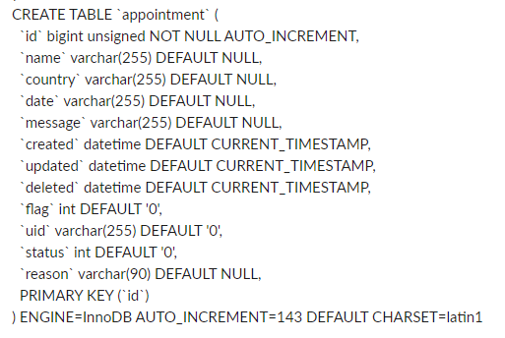**Annexure A: Data Structure**

**Announcement**

**Blog**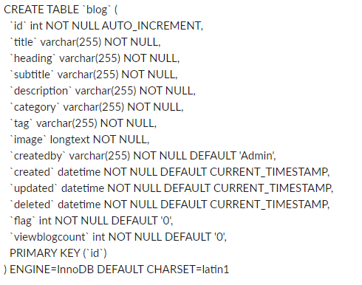

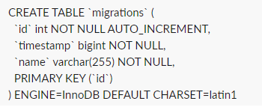**Migration**

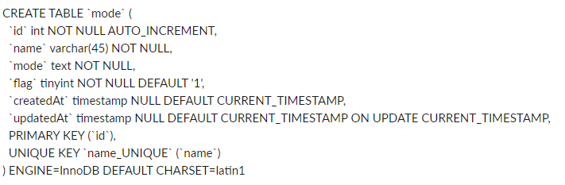**Mood**

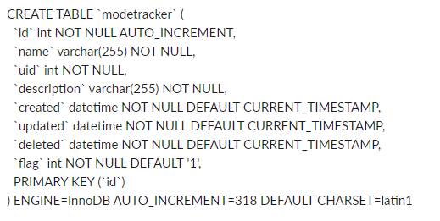**Mood Tracker**

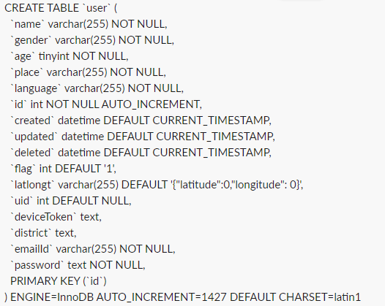**User**

# Annexure B: Entity-Relationship (ER) Diagram

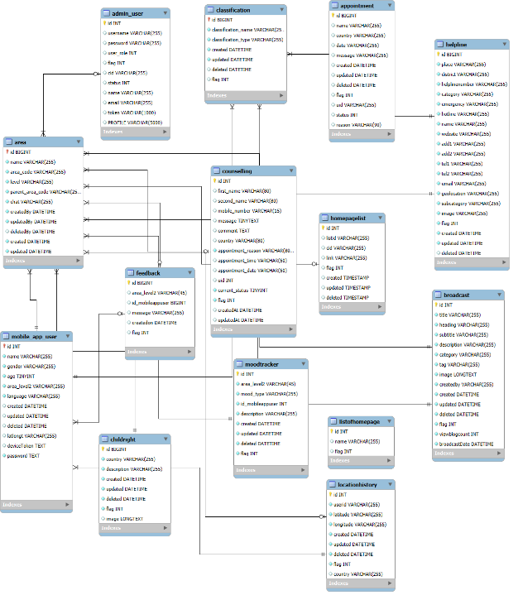

# Annexure C: Mobile App Wireframe

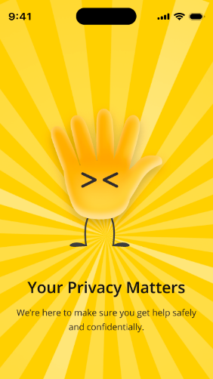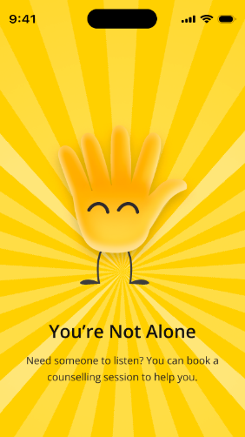

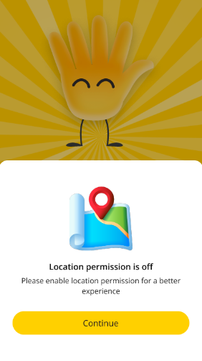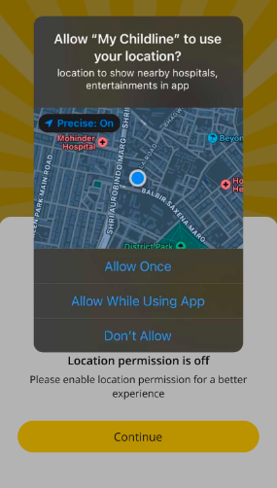

**Register**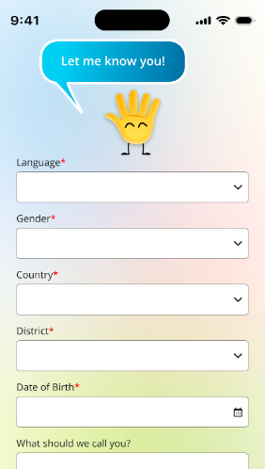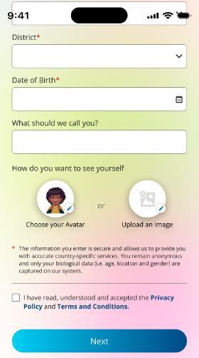

**Avatars**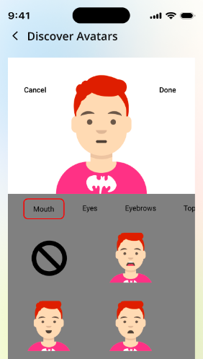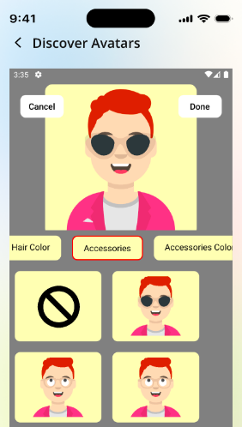

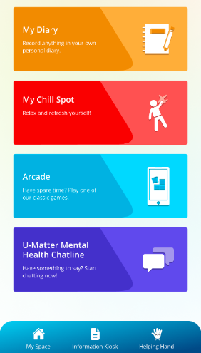**My Space**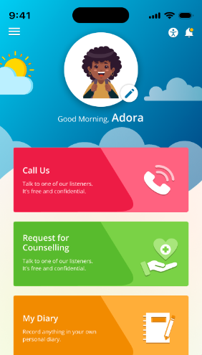

**Helping Hand**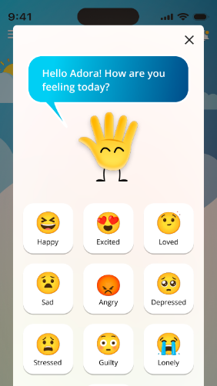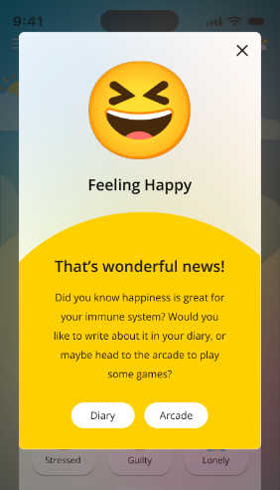

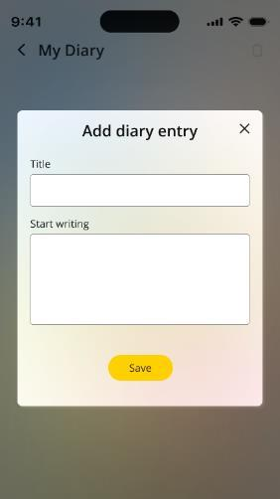**My Diary**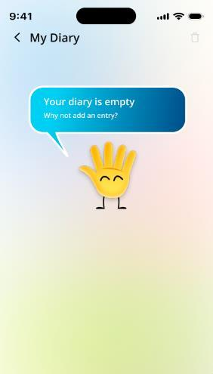

**My Diary**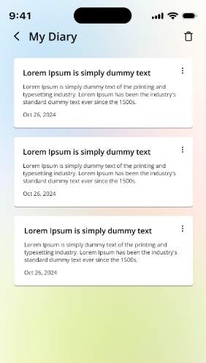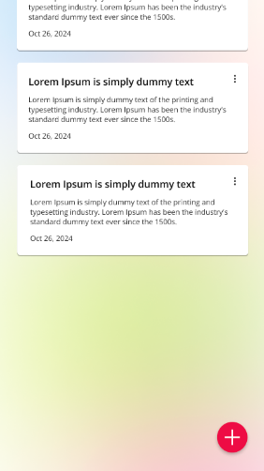

**Request for Counselling**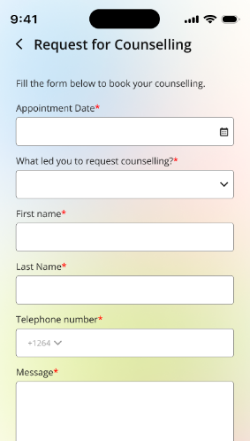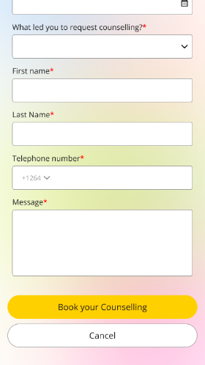

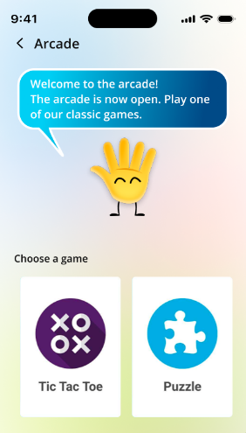**My Chill Spot and Arcade**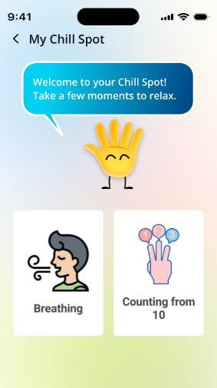

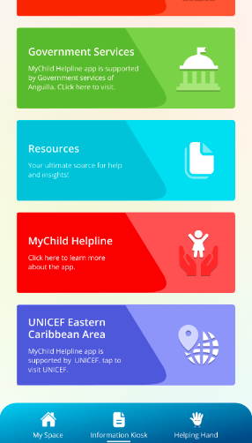**Information Kiosk**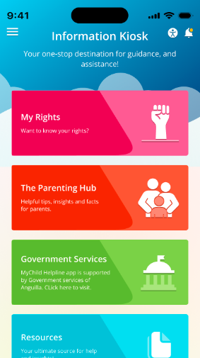

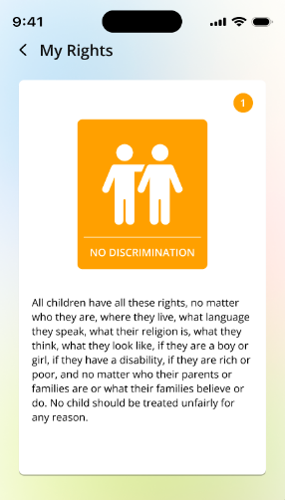**My Rights**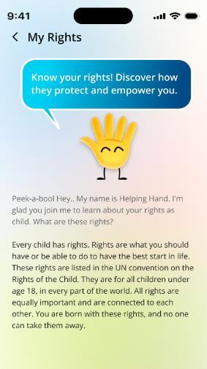

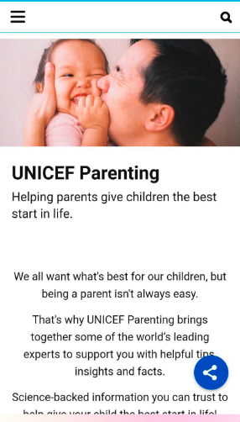**The Parenting Hub**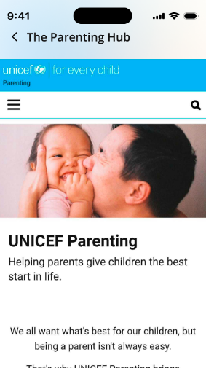

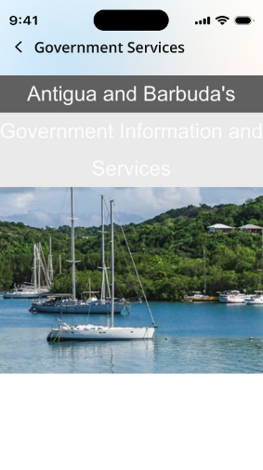**Government Services**

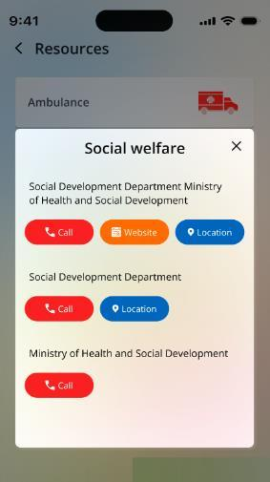**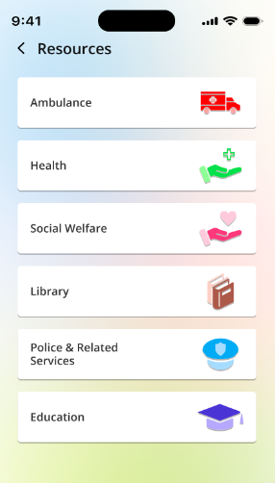Resources**

**Settings**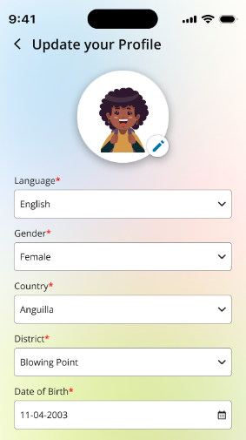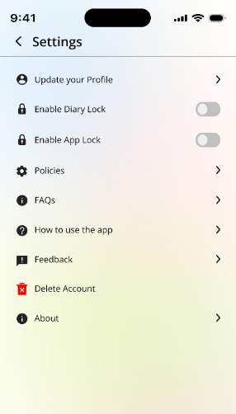

**Settings**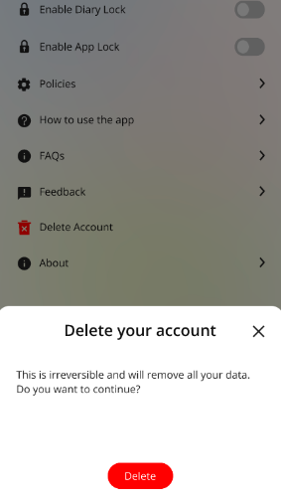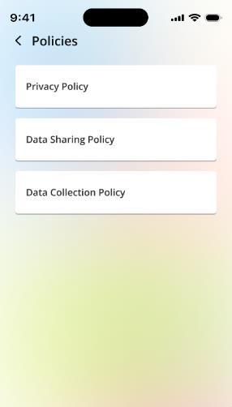

**Broadcast Messages**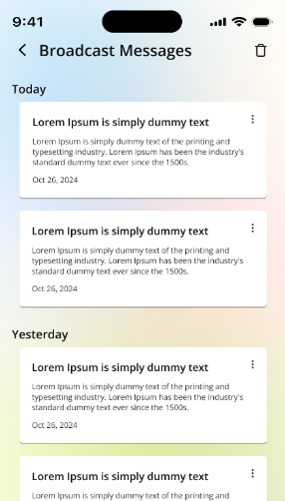

# Annexure D: Admin Panel Wireframe

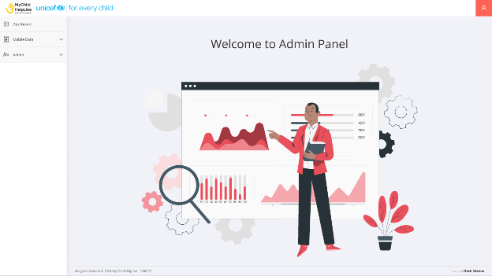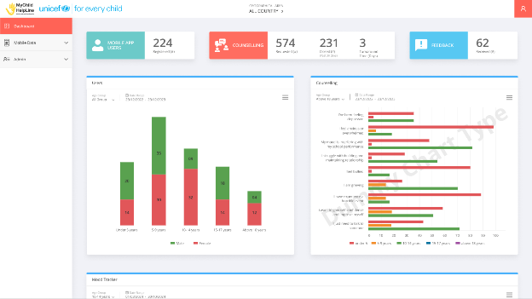

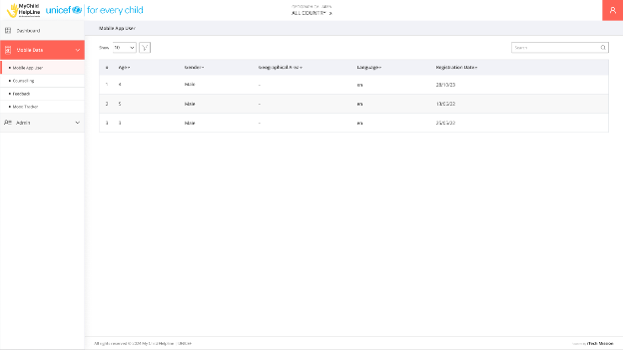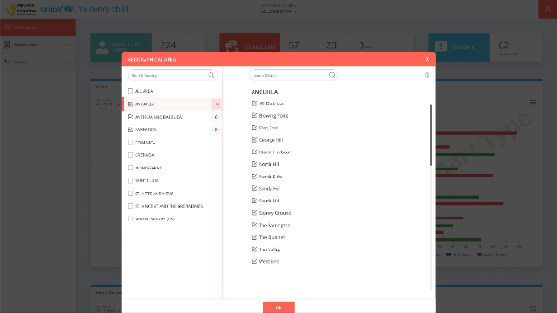

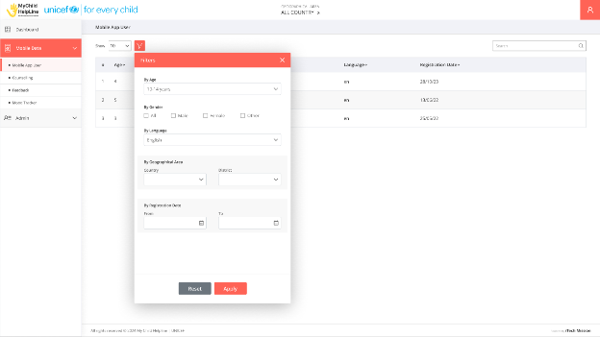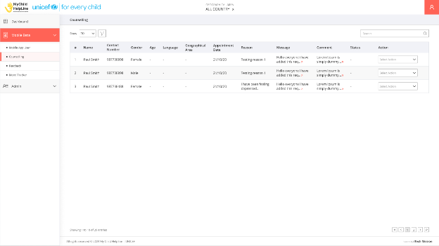

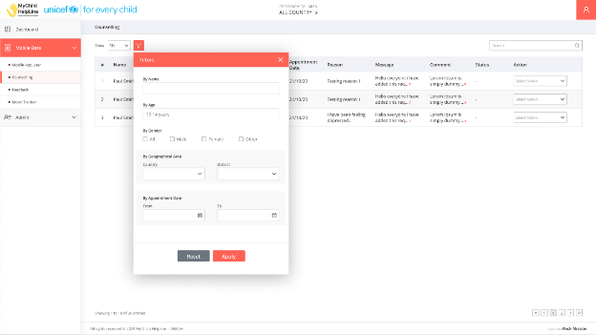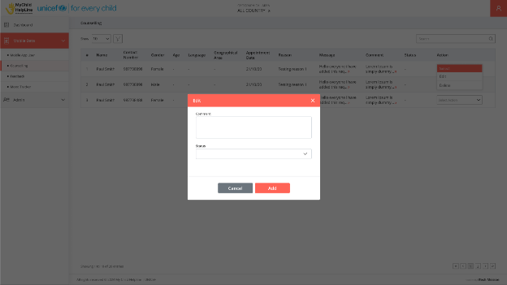

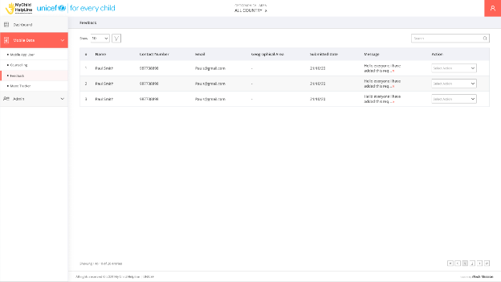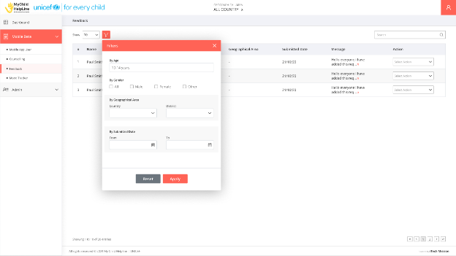

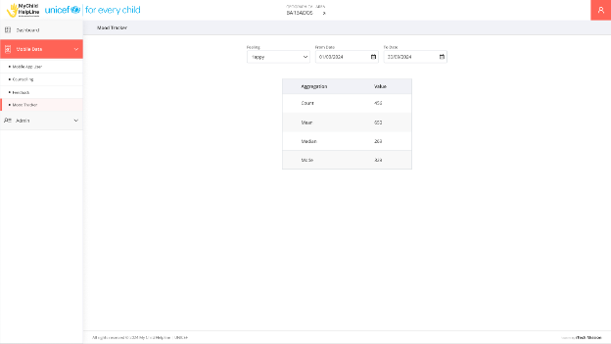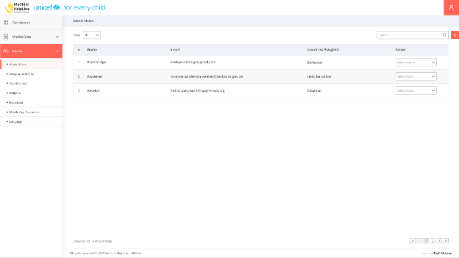

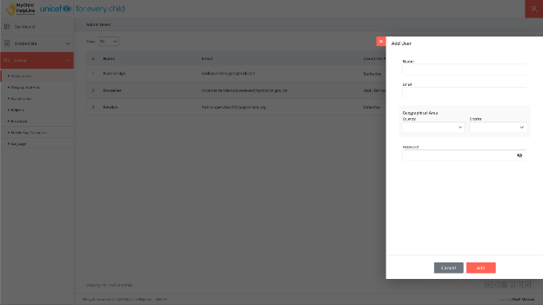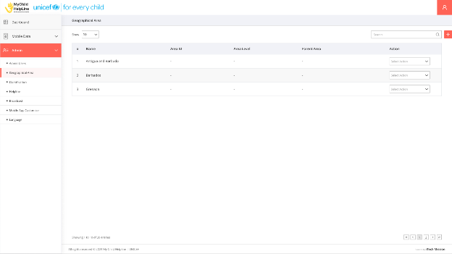

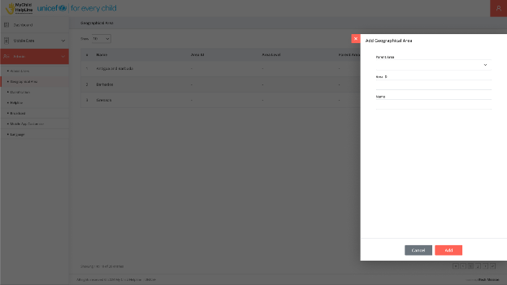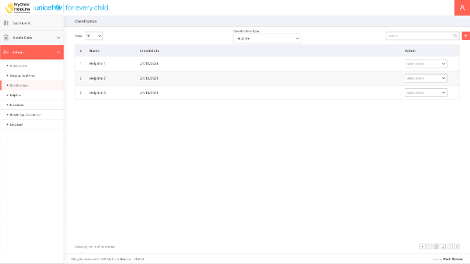

--- End of the Document ----